**Image Processing Project 4**

**Materials and Implementation of**

**(one week)**

**Image Processing Part**

1. Learn the concept of remote sensing images (e.g. Hyperspectral images, multispectral images, SAR images, etc.) and compare them with ordinary images.
2. Which features can be extracted from remote sensing images? Explain the difference with other kinds of images.
3. Learn difference remote sensing image classification methods and take three or four examples in detail. For example, understand the process of SDAE (stacked denoised autoencoder) and the usage of it in remote sensing image processing.

**Machine Learning Part (The link is for reference only)**

1. Learn the concepts of loss function and take some examples.
2. Which ways can prevent the Gradient Vanish in CNN?
3. Learn the concept and usage of Tensorflow (CPU and GPU).
4. Install Anaconda/Python 3.6, and Tensorflow cpu.（open cmd and input the following codes)
5. To verify the installation of python
6. python –version
7. Update pip (or pip3)
8. python -m pip install --upgrade pip
9. Install tensorflow
10. pip install -i https://pypi.tuna.tsinghua.edu.cn/simple tensorflow --upgrade
11. 4) install pillow
12. pip install -i https://pypi.tuna.tsinghua.edu.cn/simple pillow
13. 5) verify the installation of tensorflow
14. python -c "import tensorflow as tf; print (tf.__version__)"
15. Install pycharm and the related environment, then input the following part to import tensorflow.
16. # -*- coding: UTF-8 -*-
17. import tensorflow as tf
18. print (tf.__version__)
19. Try some small examples on Internet and there are some solutions to the problems may be occurred in the above step.

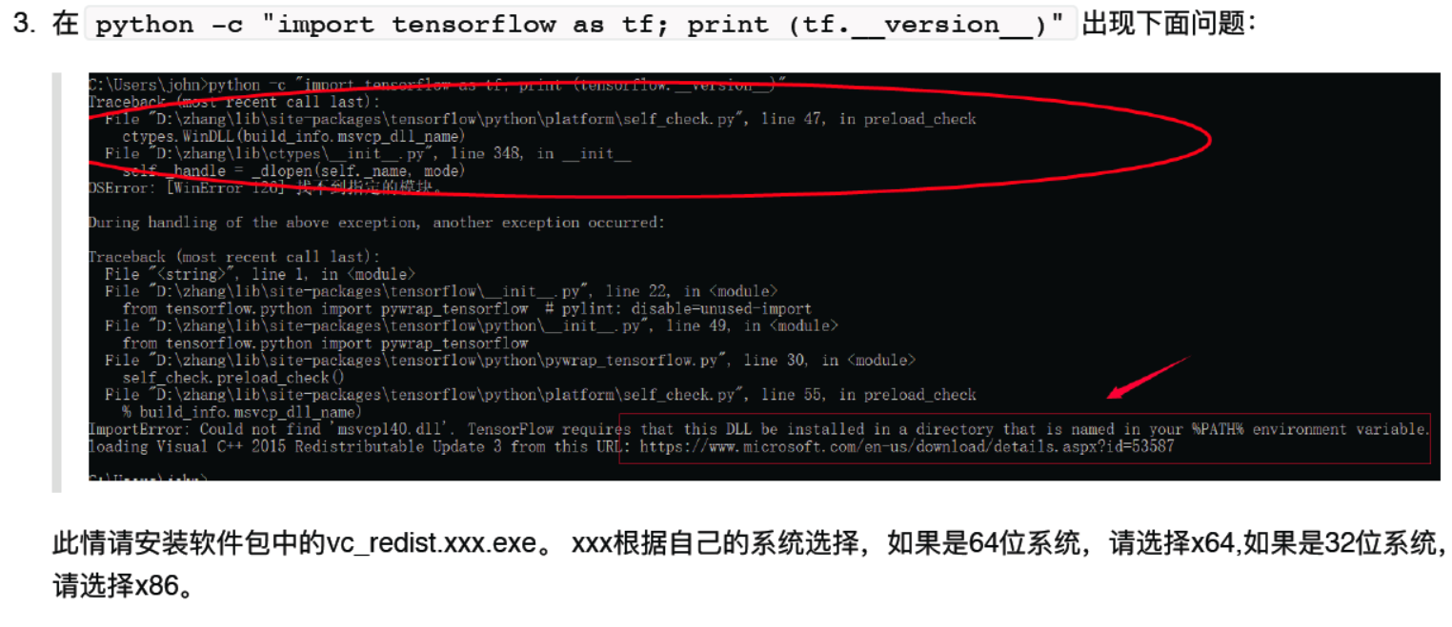

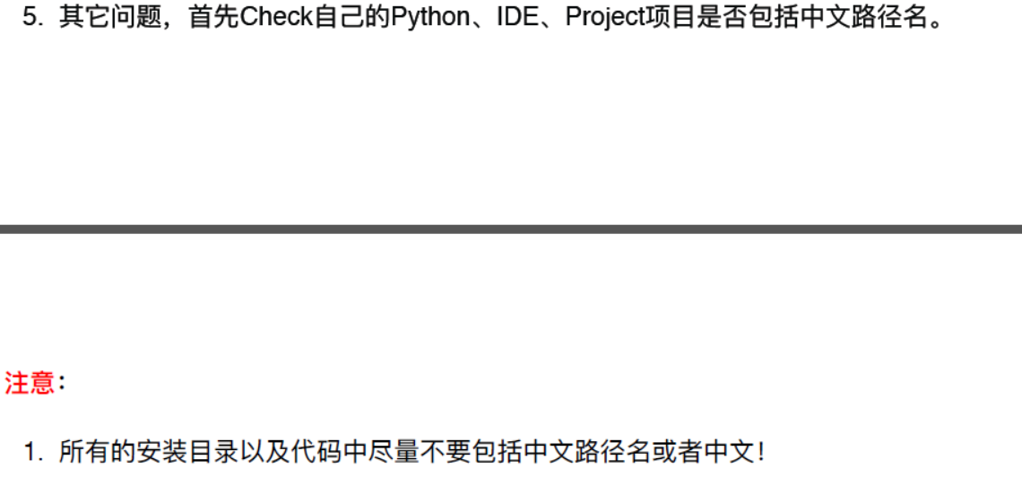

**Submission:**

(1) You should show me a project report with your source codes as appendix. One sample reports is attached for your reference.

(2) You are expected to give a 20-minute presentation in English to me (recommended) such that I will know how much you have learnt from the project. You also are recommended to send your PPT file to me before the presentation day.